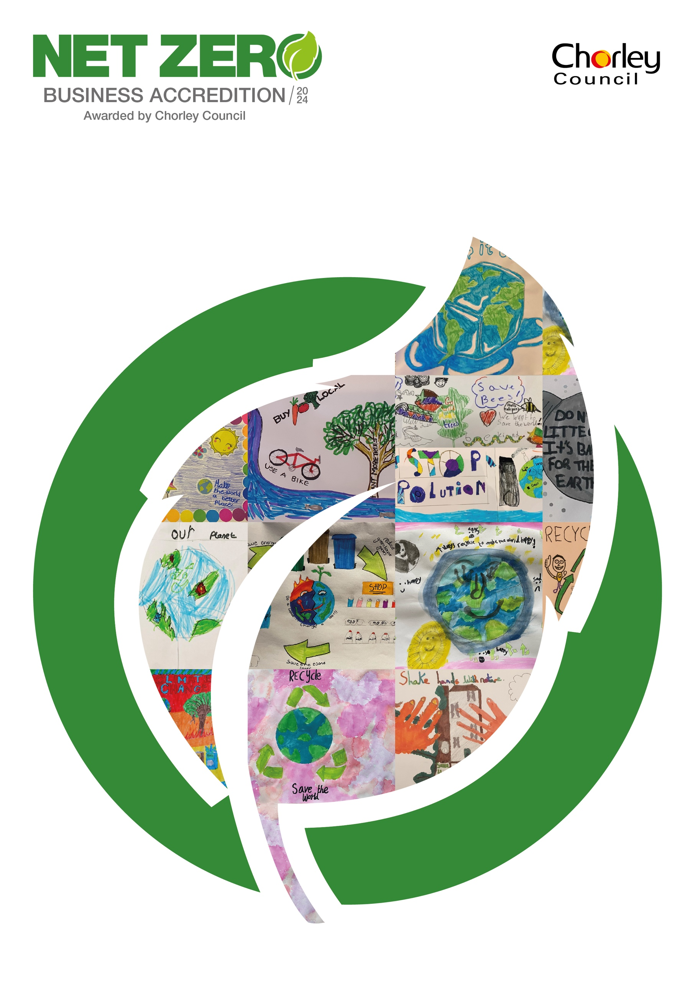

Net Zero Business Accreditation Scheme Support Document
The Net Zero Business Accreditation scheme is a fantastic opportunity for your business to showcase all the work it is doing to help Chorley and the U.K. reach its ambitious target of net zero by 2030. We want Chorley to lead the way in net zero innovation and show that together, as a community we can create a sustainable legacy for generations to come.
We hope that this will award and the fantastic work your business has undertaken to inspire and have a ripple effect to all business around the borough to improve their sustainability.
The Council have created the Net Zero Business Accreditation Scheme to recognise and celebrate the work businesses are completing to support the borough in becoming net zero by 2030.

What signing up to the accreditation entails
With a large number of businesses in Chorley the judging of the accreditation will need to be thorough. Applications are largely open answer, covering a number of topics in order to gain a thorough understanding of your business and all the environmental measures which have been taken. The application will be the only source of information when marking businesses to make a long list, so ensure that all relevant information is provided with the application within relevant sections.
Applying to be accredited through Chorley Council is a borough wide scheme. Businesses outside of the borough cannot apply. Information will be stored for a period of 2 years. Applications will be reviewed by our long list volunteer reviewers and our short list judges. For further details regarding the judging procedures refer to ‘Judging Format for the Scheme’.
This supporting document provides guidance and examples to use when writing your application. For each section there are examples given, please feel free to add anything you feel is relevant, this is by no means an exhaustive list.
Those accredited per year is limited to 10 businesses, but businesses can repeat applications annually. The accreditation once awarded will not require any renewal. However, as a Council we will be continuing communication to follow business progress as they continue on their journey to Net Zero.

Council offered benefits following accreditation.
We want to celebrate your exceptional work through this accreditation scheme and if you are accredited your business will be included in communications delivered by Chorley Council including:
- A placement on the Chorley Council website as part of a directory of businesses in receipt of the accreditation
- A press release relating to the accreditation.
- A yearly feature on our social media channels outlining the successful accredited businesses.
- Be used as a case study we use to highlight excellent practice (with permission from the applicant).
- Be part of other ad-hoc opportunities the council may generate to promote the accreditation.
Each accredited business will be provided with a plaque to be displayed within their businesses and online .png plaque to be used online with websites, emails social media channels. All plaques will be presented to accredited businesses by our Executive Member for Environment.

Judging Format for the Scheme
The application form for consideration for the Net Zero Business Accreditation is an open answer response form. This allows you as a business to cover all the methods and actions you have taken to lower your carbon footprint and mitigate climate change.
All applications will be marked based on marking criteria built from the support document material provided within this document. The highest scoring 20 applicants will be longlist to progress to the next stage for in-person interviews by our panel of judges.
In-person interviews will be hosted at our Strawberry Fields Digital Office Park, Chorley. Each Business will send a representative to answer questions relating to the application submitted and any additional details on the business the judges may have. Interviews will last for approximately 20 minutes for each business.
The accreditations are judged by a panel which have strong links with climate change learning and championing and business from both within Chorley and in the surrounding area. The panel of esteemed judges have extensive knowledge of environmental and business fields allows them to judge the work completed by the business. The type and size of the business will be taken into consideration.

Methods and examples of work a business can complete to be awarded with the Chorley Net Zero Business Accreditation
The following points are written as a reference guide when writing your application. It is not required that you cover all the points mentioned below and you may have additional relevant information which has not been referenced here. This guide will also be used by the award committee for reference however it is not a marking criteria. The award committee will also use their own professional expertise and knowledge to judge applications.
- Environmental ethos of your company
To make lasting environmental change, sustainability and the environment should be driven through the vision and ethos of your company.
- Does your business have a sustainability action plan already? If so, what are your priorities and how do you drive this change?
- Does often your business engage with climate action? (e.g., do you discuss this as part of meetings and at senior levels within the business)

- Energy supply /reducing carbon footprint
The supplier of our electricity can be one of the fastest ways to lower a business’s carbon footprint. The starting point for this is measuring the carbon footprint of your business and from this you can look at ways to reduce it.
- Monitoring carbon footprint (can this be quoted) What is the carbon footprint, have actions been taken to lower the footprint, can a downward trend of the footprint be evidenced following actions taken.
- Does your business only purchase energy from a 100% renewable energy supplier?
- Do you still run off gas in your business or has your heating and cooking been covered to electric only to lower your carbon footprint?

Energy efficient buildings
The efficiency of a building can be a very useful tool for conserve the heat produced within a building thus lowering the amount of energy required to use you building. Therefore, this can have an impact on not only your carbon footprint but also potentially reducing your energy bill.
- Do you know the EPC rating of the building you use?
- Have you done any work to improve the energy efficiency of the building such as double glazing, additional wall, or loft insulation?
- When deciding the building you purchased or rent, was the EPC rating of the building a consideration?
- Does your building use renewables for part of the energy mix? This could be physically on site or an energy contract with a company using renewable energy.

Energy saving measures/reducing carbon footprint
Energy saving measures are also a good way to save your business money whilst also doing something positive to help the environment.
- Have you installed a SMART meter, so you are aware if your energy usage on a day-to-day basis?
- Do you use LED light fittings?
- Have you replaced any single glazed windows with double glazing installed any wall or loft insulation?
- How do you ensure appliances are switched off overnight and when they not in use?

- Travel and fleet, lease cars
The top contributor to climate change in Chorley is from the fumes produced by transportation: cars, vans, lorries etc. Does your business have a sustainable transport plan for both commercial usage and to encourage more sustainable working options for your employees?
- Moving to an electric vehicle fleet or using biofuel instead of diesel or to reduce the travel of your employees.
- Opportunities to work from home.
- EV charging points for employee usage at the office.
- Use of technology to reduce ‘in person’ meetings.
- A cycle to work scheme and the provision of cycle lockers and a shower to enhance usage.
- A lease scheme which provides incentives for employees to convert to electric vehicles.

- Waste reduction measures
Reducing waste in the first instance is the biggest way your business can reduce waste overall. It is important to reduce our overall consumption of ‘stuff’ in order to reduce the amount of energy we are producing to make these.
- Do you think about sourcing products/goods with reduced packaging or packaging that can be reused or recycled?
- For any goods/products made by you, do you use less packaging or use recyclable packaging?
- Has your business taken any actions to lower the waste you produce and also how much of this waste is recyclable? If you have any examples of methods you have taken to lower your waste, these will be beneficial in your application.
Within Chorley, for our households the recycling rate is currently ~45%. The Council is working to improve this to 65% by 2030 to align with the Government’s target.
- Does your business have recycling targets?
- If yes, how far off are you meeting this target?

Recycling Rates
The best way to deal with waste is to reduce waste in the first instance.
- Has your business monitored how much waste, by weight or unit measure, is produced on a monthly or annually basis? Has your business monitored how much of this waste is currently being recycled?
- Has your business taken any actions to lower the waste you produce and also how much of this waste is recyclable? If you have any examples of methods you have taken to lower your waste, these will be beneficial in your application.

- Community Engagement
Community engagement and education is an essential part of forming a climate friendly community. Conversations and learning can be a powerful tool when trying to change habits. Engagement leads to actions and mitigation which supports the borough’s goal of being net zero by 2030.
- Does your business support or fund community groups which complete community mitigation actions such as litter picking, tree planting or education?
- Does your business complete actions to support the community such as cosy spaces, price reductions for certain groups in the community?
Alongside your business’ wider community engagement, how is your business engaging with sustainability /green issues with your employees?
- Do you have a ‘Climate Change Champion’? Have you had any Carbon Literacy training delivered to your employees?
- Does your business actively engage with any climate change networks?

- Engaging staff or teaching staff
Education and conversation are important around environmental issues, these facilitate learning and help to develop understand of the complexities around climate change and reaching net-zero.
- Do you have an ‘eco’ notice board to show staff what the business is doing to be more environmentally conscious?
- Do you sign post staff through emails/newsletters etc on how they can reduce energy in the office or when working at home?
- Have you undertaken any carbon literacy training for your staff members?

- Locality of Supplies
Supplies which are produced or grown locally often have a lower footprint as the transportation to your site is significantly lower than those purchased and shipped from abroad.
- Are you able to quote how much of your supplies are provided from within Lancashire and from the UK?
- Do you work with other local businesses to complete work rather than using businesses from outside the borough?

- Environmental funds – pension companies or banking
Are you aware of the industries used for investment in your pension schemes? For example, do they invest in fossil fuels, or do you use a bank that invests in renewable energy? Does your bank have community investment schemes?

- Sustainable water use
As the impacts of climate change become more common, we will experience drought events more often, so saving water all year round can help to keep reservoirs stocked up. Has your business implemented water saving measures?
- Installed slow flow taps?
- Use of ‘water hippos’ in your toilet tanks to reduce water used when flushing?
- Reuse water through a grey water system?

- Improving natural habitats – litter picking, tree planting
As a business community there are many ways in which you can improve the natural environment around you. Your business could have some open space where you could:
- Take part in ‘no mow May’.
- Plant more wildflowers.
- Install bird and bat boxes.
- Plant more trees.
- Or you could encourage your employees to take part in a litter picking event around the locality of your business.

- Future plans
We fully understand that for many businesses this is a period of transition to a more sustainable business model. We would like to know what your plans are for the future and how you plan to implement them.
Net-Zero Innovation
This is a special section. It is intended to highlight any innovative projects that your business is currently undertaking to help reach the ambitious local target of net zero by 2030. It may be a project that has already been covered in another section, but if you would like to give further detail. Alternatively, it could be something that does not quite fit with the other criteria, but you feel really displays your business’ commitment to net-zero.
These innovations could be listed within the support document which you have taken further or could be completely original and specific to your business. With this innovation have you:
- Have you subsequently lowered you carbon footprint or those of the community? If so, how?
- Is the community involved in this innovation project?
- Has the innovation lowered your transport emissions in any way?
- How are you engaging with employees, customers in its environmental efforts?

Special recognition can be awarded during scoring and judging for deserving work in this category.

*We fully appreciate that size, service type and building ownership type have a bearing on delivery of some environmental/sustainability objectives. These are points and ideas to guide you in the completion of your application. Each application will be considered on its own merits.

